# NodeMCU V3 ESP8266 ESP-12E Arduino CH340 WiFi Board

<https://shopee.ph/NodeMCU-V3-ESP8266-ESP-12E-WiFi-development-board-i.18252381.242351891?ads_keyword=wkdaelpmissisiht&adsid=8137898&campaignid=195030&position=0>

# Arduino Nano V3.0 CH340 ATmega328P 5V 16MHz Nano I/O Expansion Sensor Shield Mini USB Cable

<https://shopee.ph/Arduino-Nano-V3.0-CH340-ATmega328P-5V-16MHz-Nano-I-O-Expansion-Sensor-Shield-Mini-USB-Cable-i.20469516.2136636814?ads_keyword=arduino%20nano&adsid=3454349&campaignid=1927158&position=0>

# OBO-152 16.6mm Piezo Piezoelectric Passive Buzzer

<https://shopee.ph/OBO-152-16.6mm-Piezo-Piezoelectric-Passive-Buzzer-i.237034143.8134138690?position=12>

# YUTU C103 POWERBANK 3600mAh

<https://shopee.ph/YUTU-C103-POWERBANK-3600mAh-i.148902509.2259120810?position=9>

# 2 Pin SPST Touch ON/Off 6A 125V 2 Position Mini Miniature Toggle Switch

<https://shopee.ph/%E2%9C%85-2-Pin-SPST-Touch-ON-Off-6A-125V-2-Position-Mini-Miniature-Toggle-Switch-%E2%9C%85-i.447511770.10831451472?position=12>

# Alibaba Ali-L22 Fast Charging Cable ( Android,IOS,TypeC,4G,V3,P1000 )

<https://shopee.ph/Alibaba-Ali-L22-Fast-Charging-Cable-(-Android-IOS-TypeC-4G-V3-P1000-)-i.308543927.6852713065?position=16>

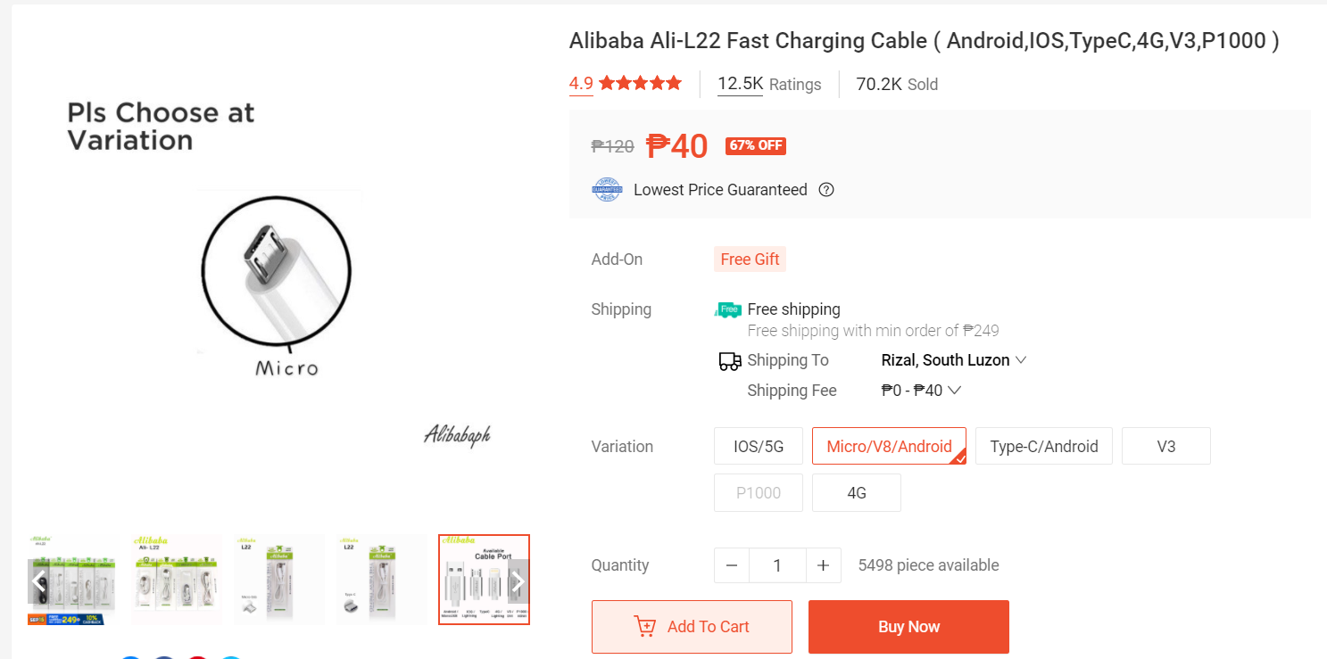

# FR4 Universal Protoboard PCB - Double Sided

<https://shopee.ph/FR4-Universal-Protoboard-PCB-Double-Sided-i.18252381.2367752523?position=5>

# Jumper Wires Arduino Dupont Line Male to Male / Male to Female / Female to Female 10 / 20 / 30 cm

<https://shopee.ph/Jumper-Wires-Arduino-Dupont-Line-Male-to-Male-Male-to-Female-Female-to-Female-10-20-30-cm-i.20469516.1363172304?ads_keyword=wkdaelpmissisiht&adsid=3610479&campaignid=2009259&position=0>

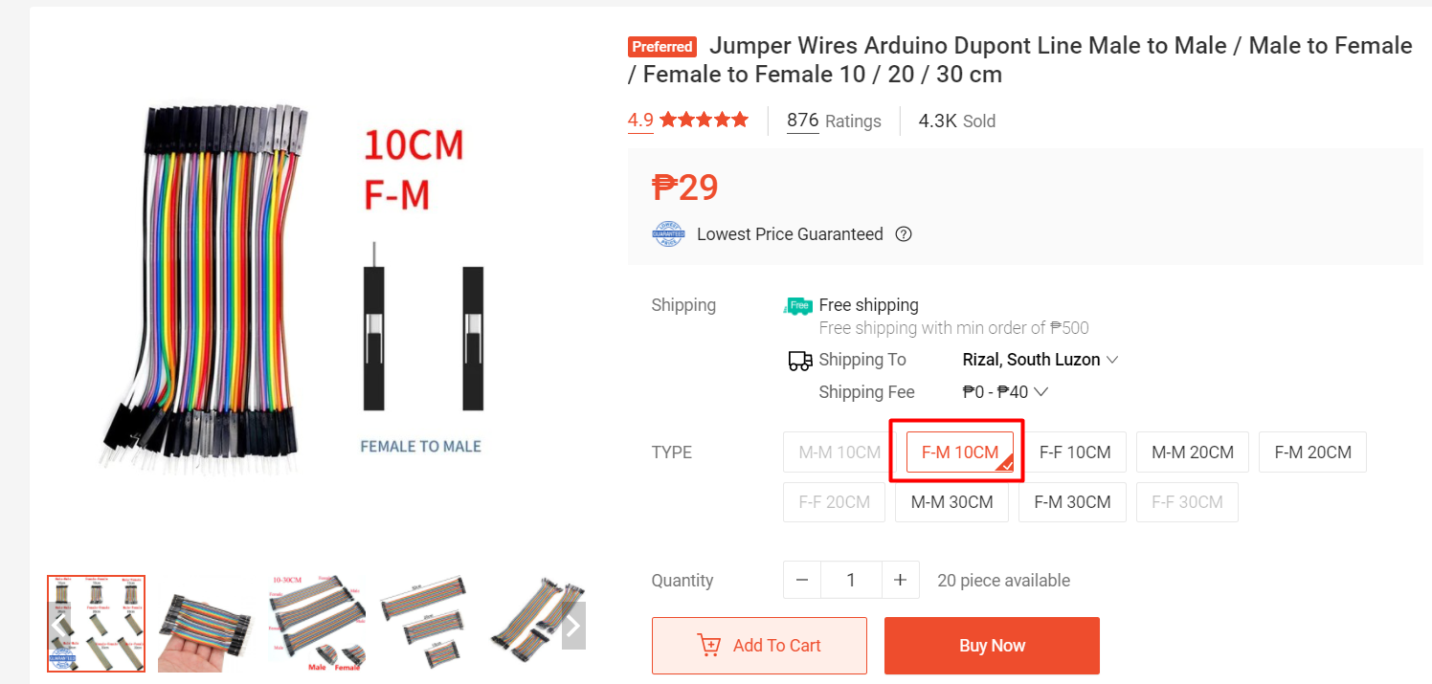

# Ishikawa Soldering Lead Solder Wire in Tube 60/40 - 2Pcs

<https://shopee.ph/Ishikawa-Soldering-Lead-Solder-Wire-in-Tube-60-40-2Pcs-i.18252381.314085149?ads_keyword=solder&adsid=4095196&campaignid=2266117&position=56>

# Enclosure

<https://shopee.ph/product/293686706/6173890703?smtt=0.332803083-1631762517.9>

